URL LINK:-<https://demo.genericsoftware.in/Login.aspx>

Click on the Result module.

Choose the

1)Financial Year 2)Fill your User name 3)Fill your password 4)Login

This will open your Screen.

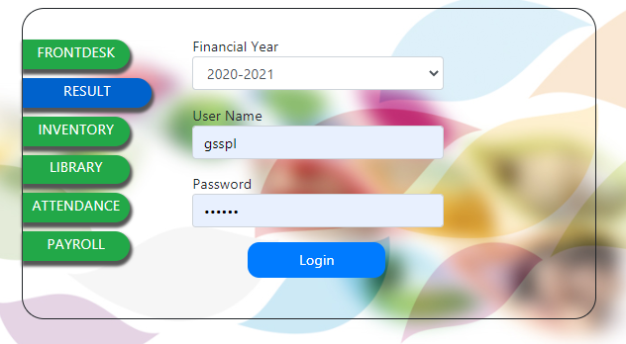

That can select your module

Master

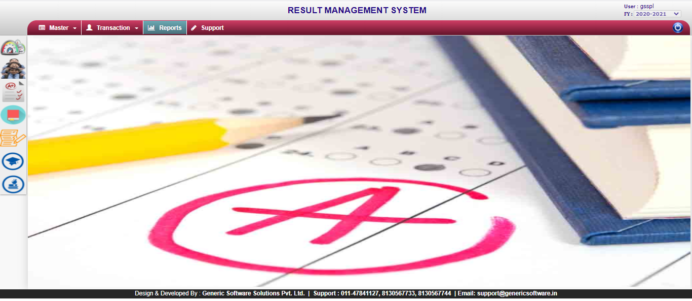

Click on your module

Master to sub module

1)Exam Term(Click)

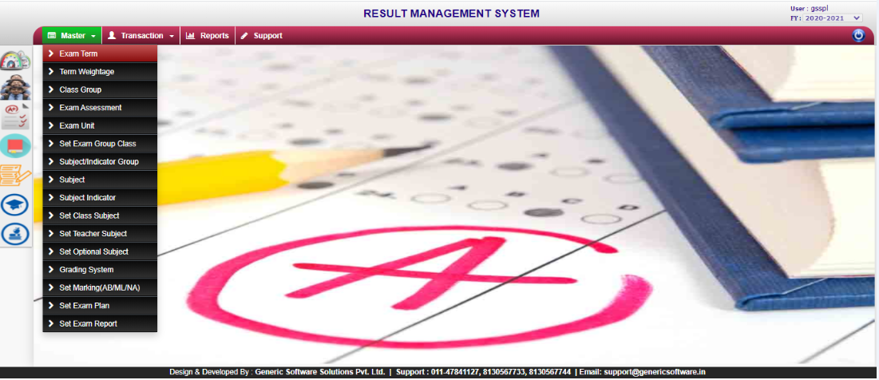

Then such a page will open on your Screen.

Exam Term:- You Can link exam terms to a question to let the system know that this particular question is an exam questions.When using exam terms,you are able to create assessment which generates assessment based on question that are linked to the exam terms.

**Procedure Name:-** USP_mstExamTerm

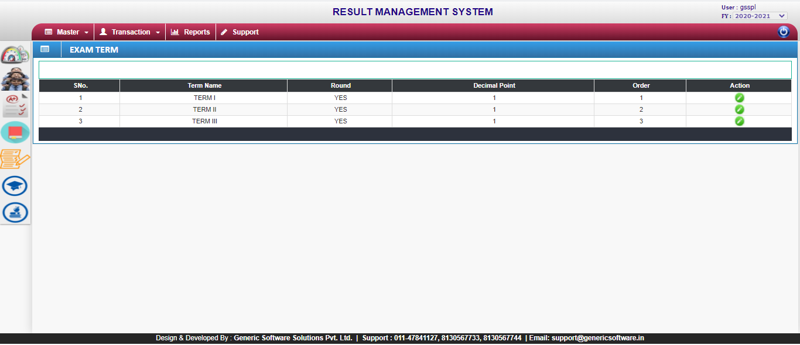

There are 3 terms.(Updated)

i)Term I ii)Term II iii)Term III

Round in marks :-Yes or No

Decimal point:-0 or 1

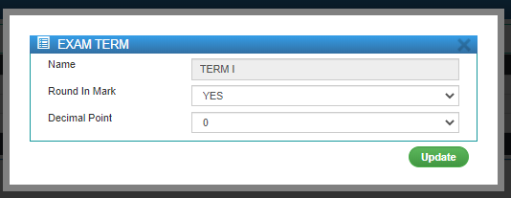

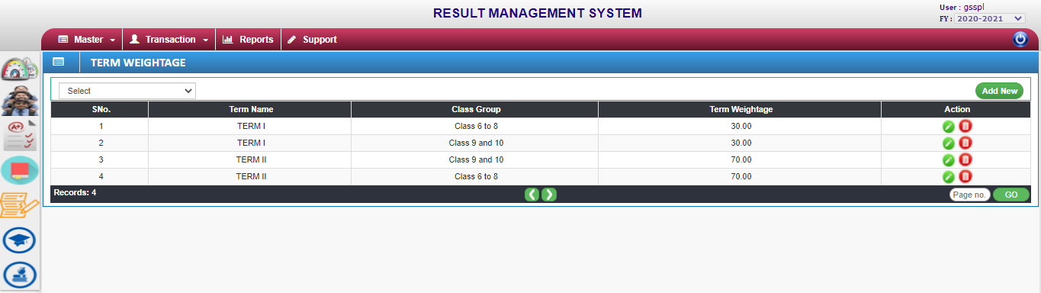

Term Weightage:-Total no. of the marks Weightage.

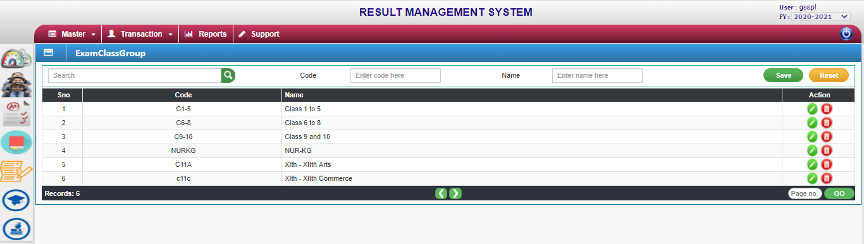

Exam Class group:-New create a Exam class group.

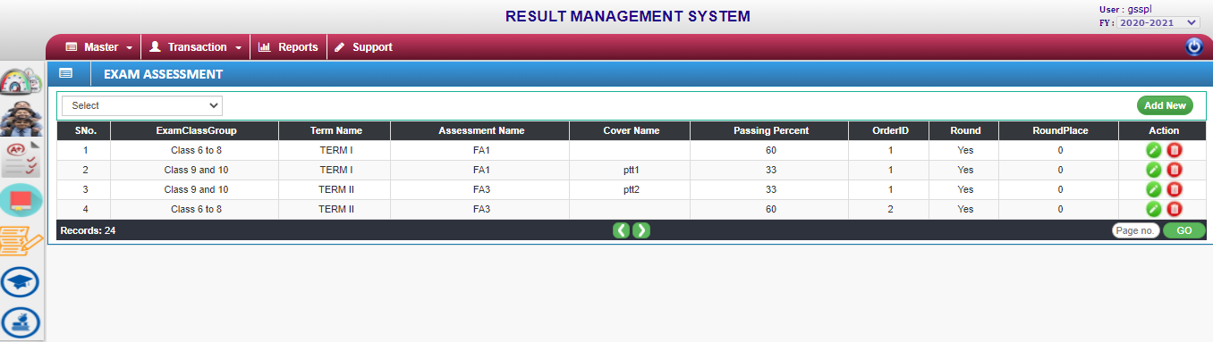

Exam Assesment:-There are 3 select of terms mode in examinations.

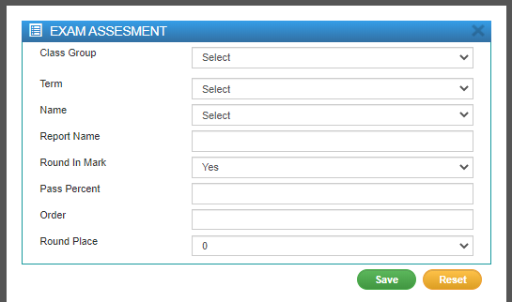

To fill all Coloumn.

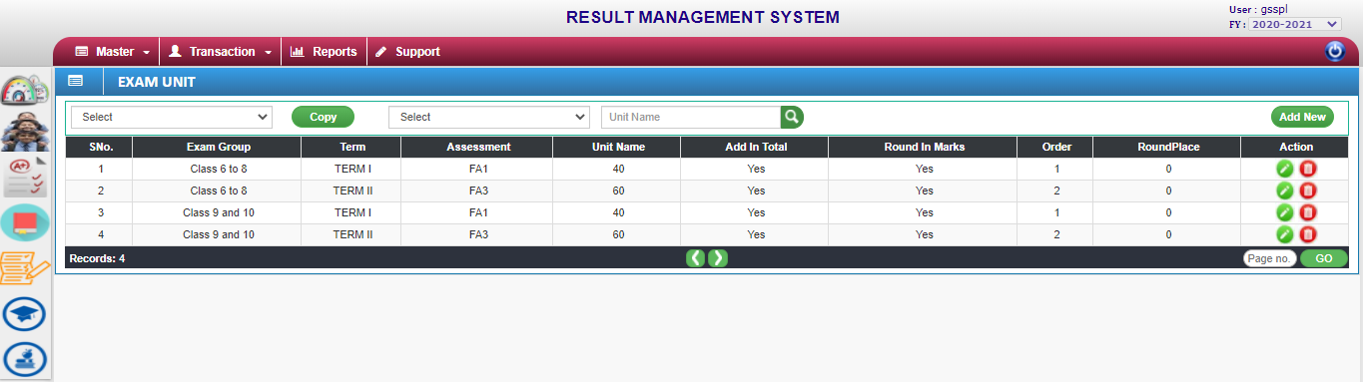

Exam Unit:-Unit fixed.

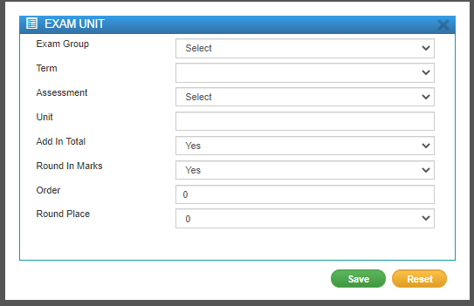

All fill the Coloumn.

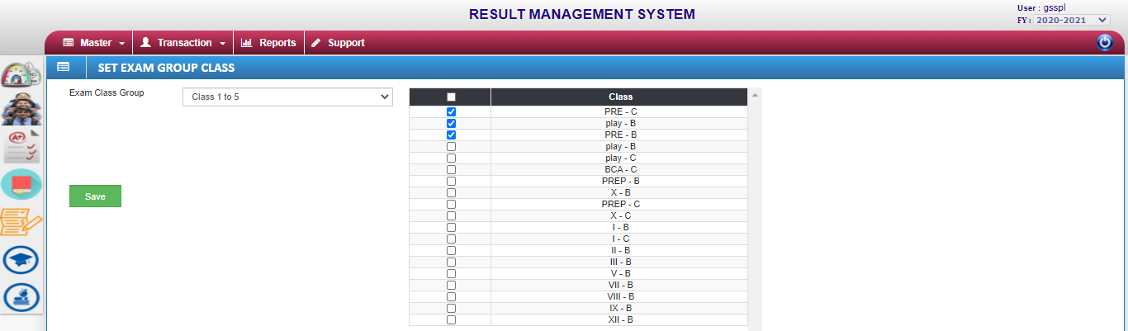

Set exam group class:-Select the exam class goup tick the Section wise class select the fields are the save.

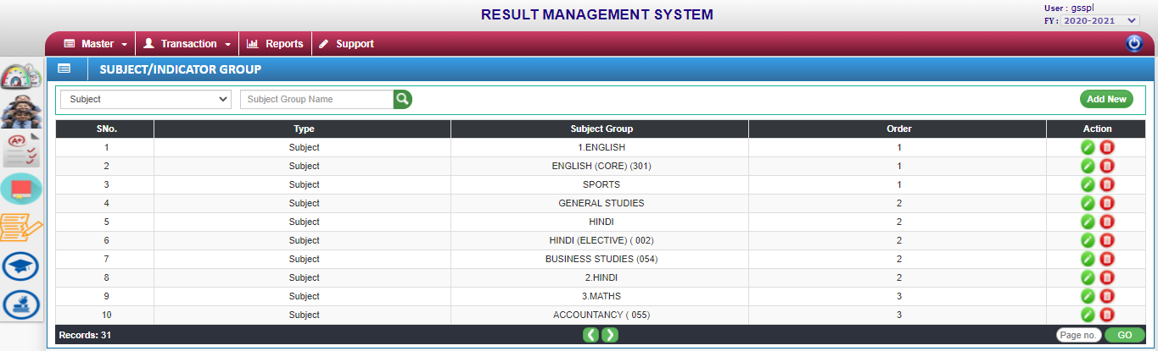

Subject/Indicator Group:-Subjects codes are fixed.

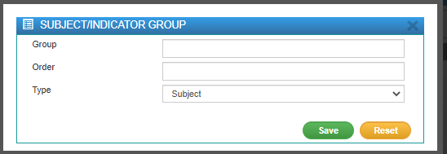

Type:- There are two types of group.

i)Subject ii)Indicator 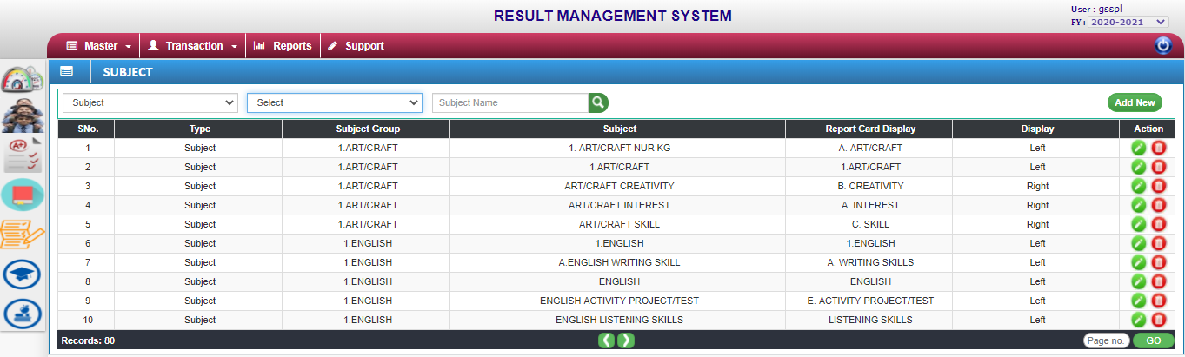

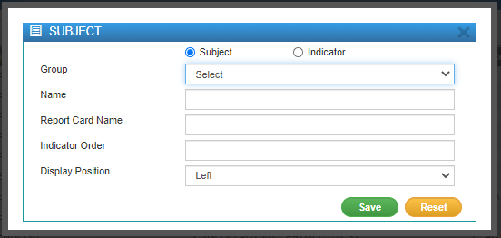

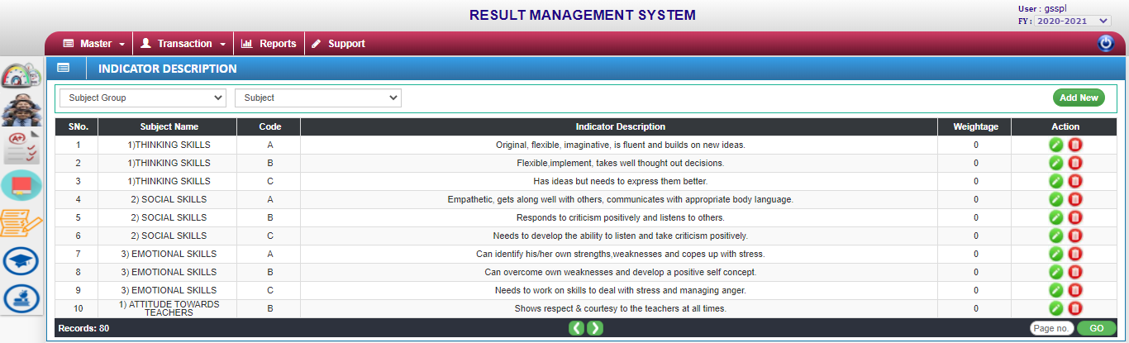

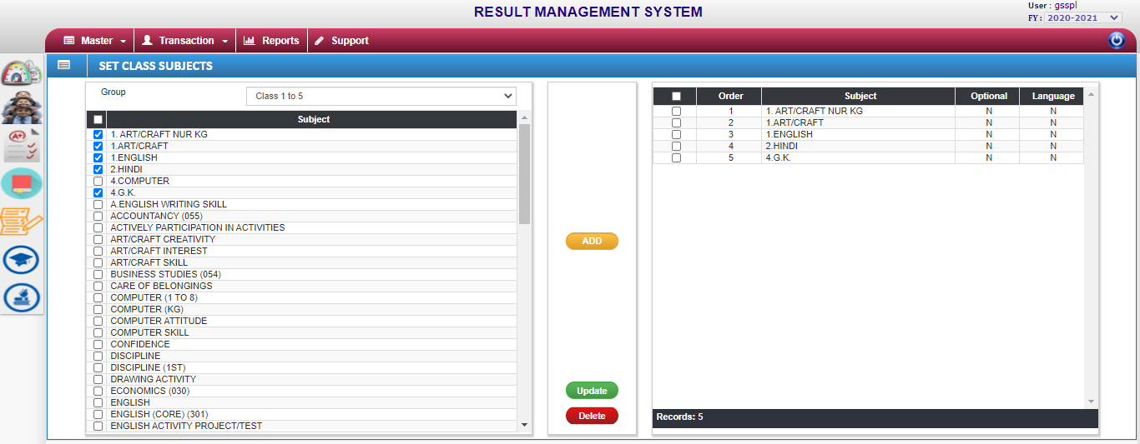

Set Class Subjects:-Select the class group.That can choose the subject list.That can order no place to Sequentially no.

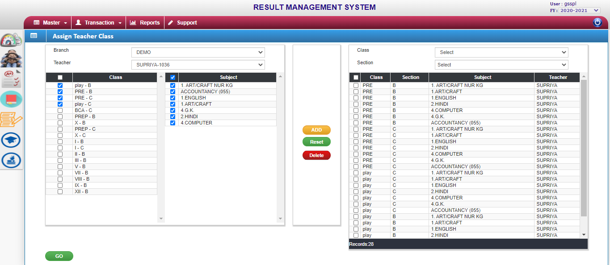

Assign Teacher Class:-Teacher name select. That can class select to list the subject name.

Go button Click the process of Assignment Class & Section its provide teacher name.

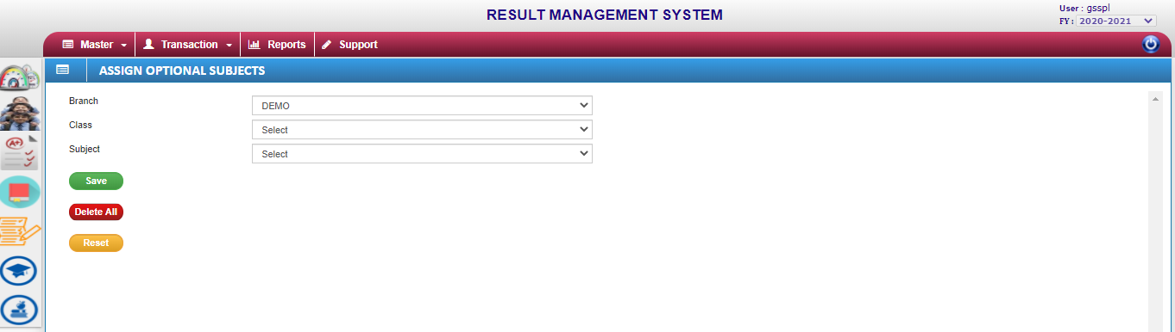

Assign Optional Subjects:-Teacher depends on select the optional subject provide to students.

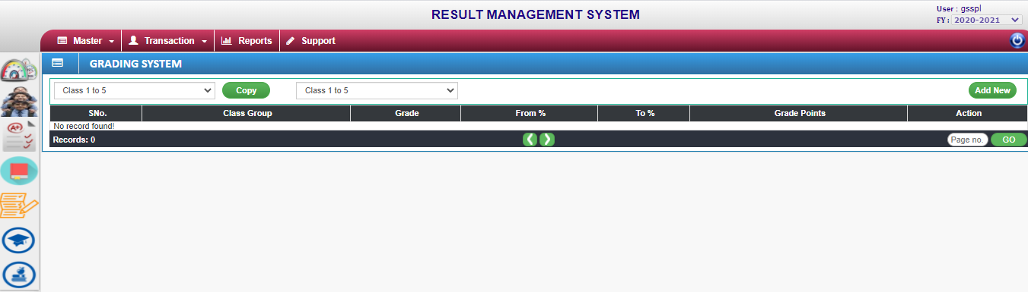

Grading System:-Grade system to utilized.

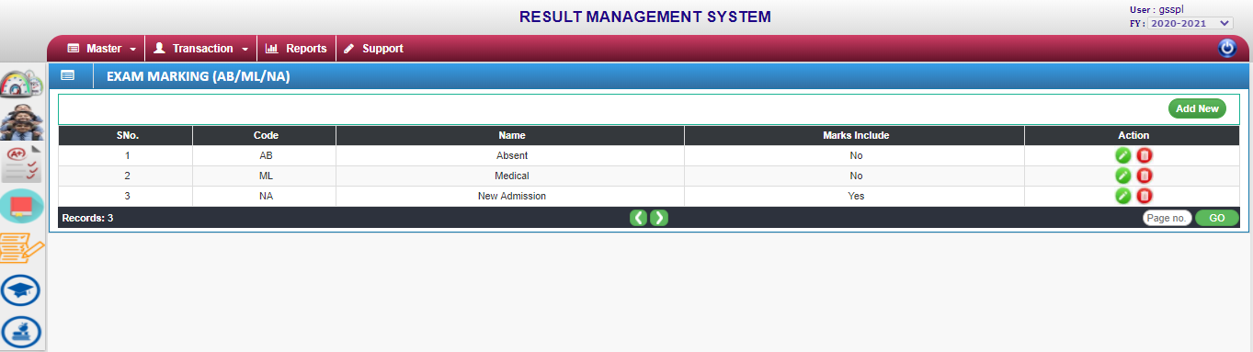

Remarks:-Reason of student exam marking.

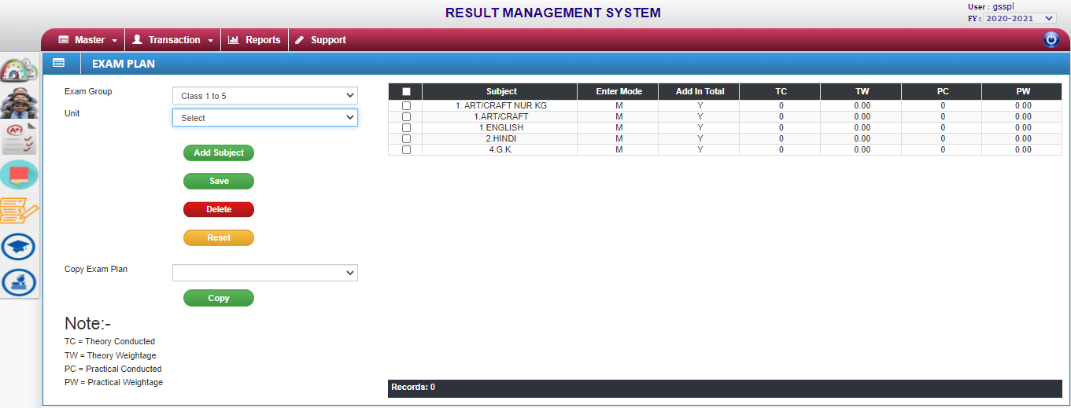

Exam plan:-Theory conducted means total no. of theory marks in obtained.

Theory Weightage means total no. of theory marks.

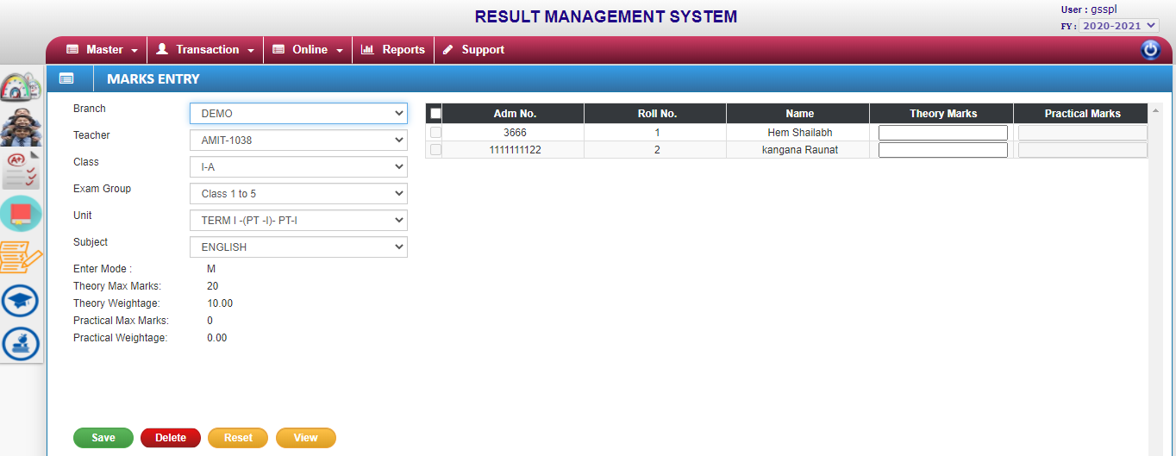

Fill the coloumn theory marks no.

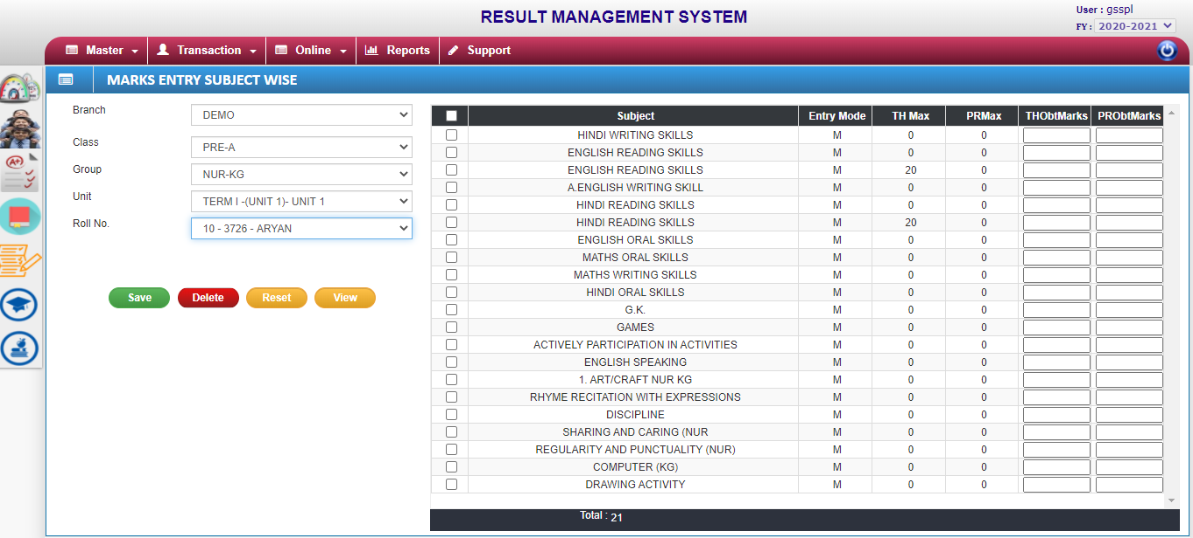

Marks Entry Subject Wise:-Subject wise marks upload.

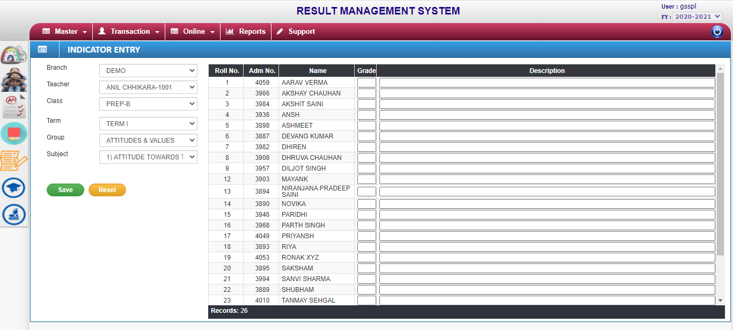

Indicator Entry:- Providing the grading system and writing decryption by not giving marks to the student in the extra subject.

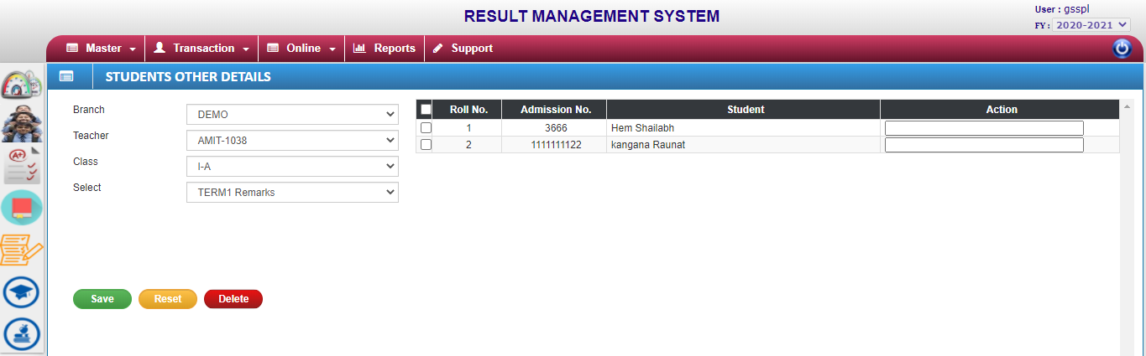

Student other details:-Select the student name Action properties in student other information fill.

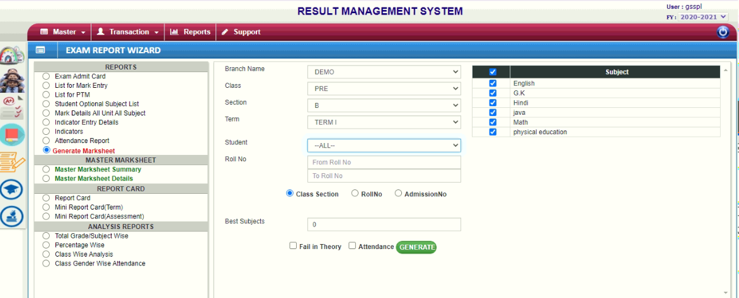

Generate Marksheet Successfully.

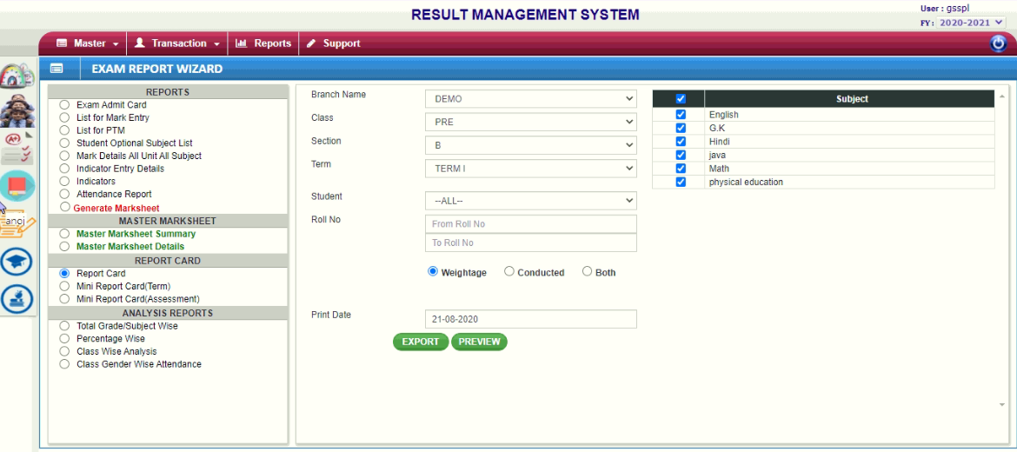

Report Card generated.

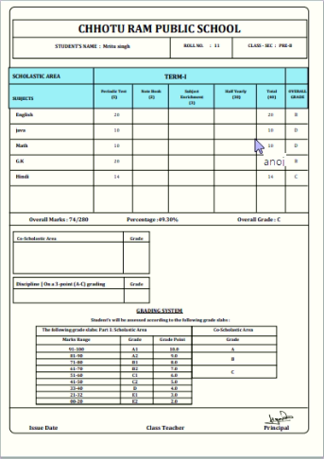

Final marksheet is open.